Assignment 7
Title: Simulation of Train Coaches Using Linked List Structures

Name: Soham Ajit Puri
Roll. No: 04
Branch: CSDS_C1

Problem Statement: Simulate how coaches (bogies) are connected in a train. Each coach is a node, and the type of list used (singly, doubly, circular) represents different train configurations. Add/remove a coach and move forward/backward between coaches.
Algorithm:
Algorithm for Singly Linked Train (Railway)

Step 1: Attach a coach
- Make a new CoachNode with the given id.
- Set newCoach->next = nullptr.
- If front is nullptr:
  - Set front = newCoach.
- Else:
  - Start from front and move until the last coach.
  - Set last->next = newCoach.

Step 2: Detach a coach
- If front is nullptr, stop (no coaches).
- If front->coachId equals the given id:
  - Store front in temp.
  - Move front = front->next.
  - Delete temp.
- Else:
  - Set current = front.
  - Traverse while current->next is not nullptr and current->next->coachId is not the id.
  - If found:
    - Store current->next in temp.
    - Set current->next = temp->next.
    - Delete temp.

Step 3: Move forward
- Set current = front.
- While current is not nullptr:
  - Print current->coachId.
  - Move current = current->next.

Algorithm for Doubly Linked Train (Railway)

Step 1: Attach a coach
- Make a new CoachNode with the given id.
- Set newCoach->next = nullptr and newCoach->prev = nullptr.
- If front is nullptr:
  - Set both front and back to newCoach.
- Else:
  - Set back->next = newCoach.
  - Set newCoach->prev = back.
  - Set back = newCoach.

Step 2: Detach a coach
- Start with current = front.
- Traverse while current is not nullptr and current->coachId is not the id.
- If found:
  - If current->prev is not nullptr, set current->prev->next = current->next; else set front = current->next.
  - If current->next is not nullptr, set current->next->prev = current->prev; else set back = current->prev.
  - Delete current.

Step 3: Move forward
- Set current = front.
- While current is not nullptr:
  - Print current->coachId.
  - Move current = current->next.

Step 4: Move backward
- Set current = back.
- While current is not nullptr:
  - Print current->coachId.
  - Move current = current->prev.
Algorithm for Circular Train (Railway)

Step 1: Attach a coach
- Make a new CoachNode with the given id.
- If back is nullptr:
  - Set newCoach->next = newCoach.
  - Set back = newCoach.
- Else:
  - Set newCoach->next = back->next.
  - Set back->next = newCoach.
  - Set back = newCoach.

Step 2: Detach a coach
- If back is nullptr, stop (empty).
- Set current = back->next (this is the front) and prev = back.
- Loop until current comes back to back->next:
  - If current->coachId == id, break.
  - Move prev = current, current = current->next.
- If found:
  - If only one coach exists:
    - Delete current.
    - Set back = nullptr.
  - Else:
    - Set prev->next = current->next.
    - If current == back, set back = prev.
    - Delete current.

Step 3: Move forward
- If back is nullptr, stop.
- Set current = back->next.
- For the given number of steps:
  - Print current->coachId.
  - Move current = current->next.

CODE:
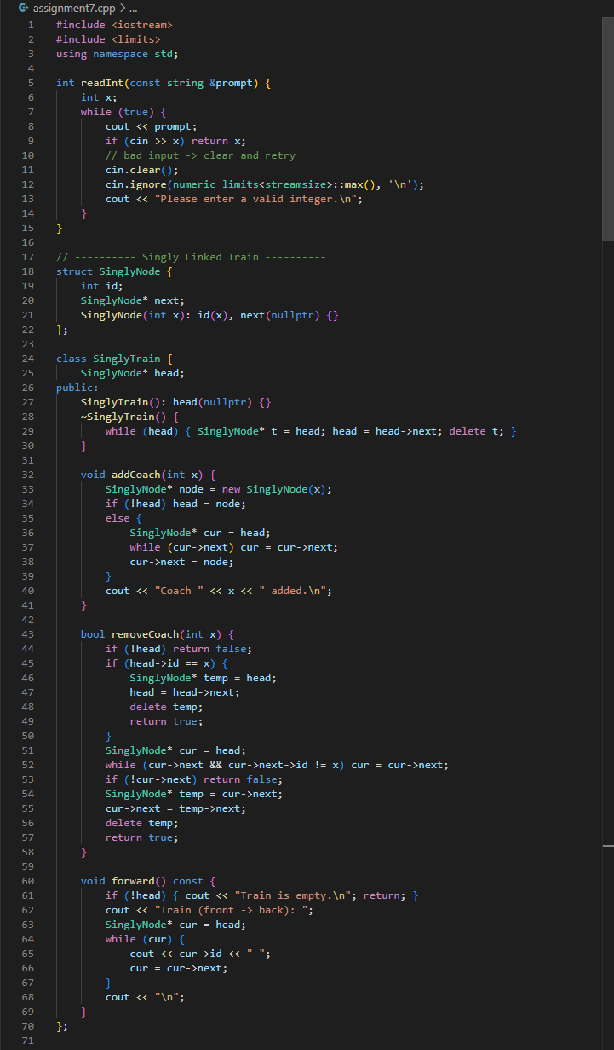
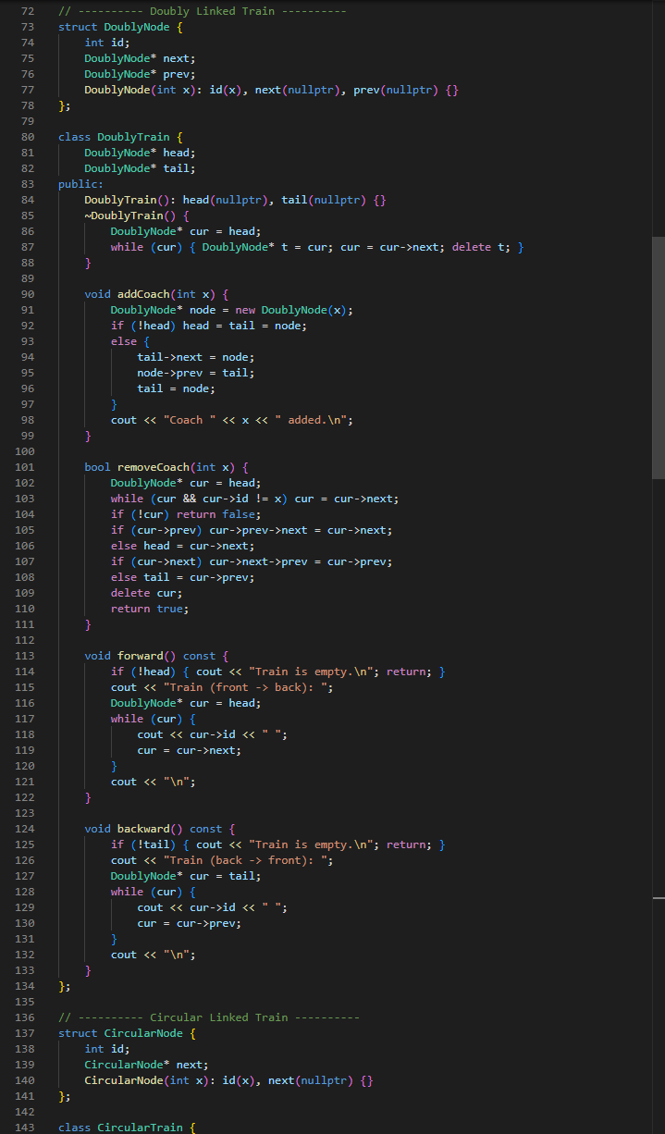
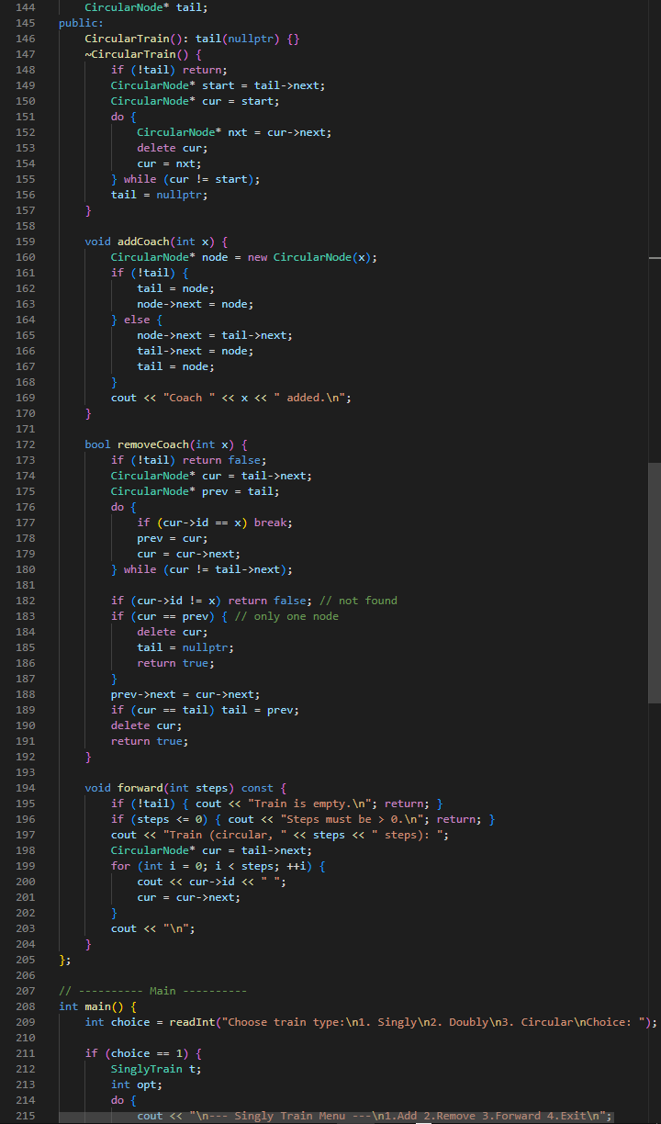
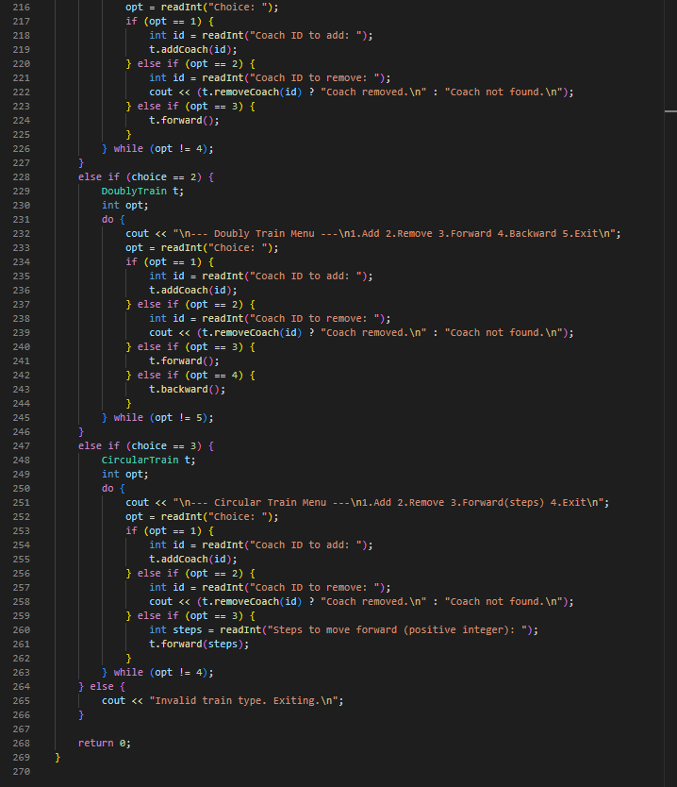

RESULTs:

Singly Linked List:

You cannot go backward here in this.

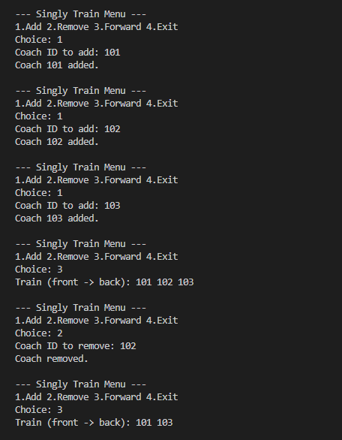

Doubly Linked List:

You can traverse both ways. After removing, backward traversal adjusts correctly.

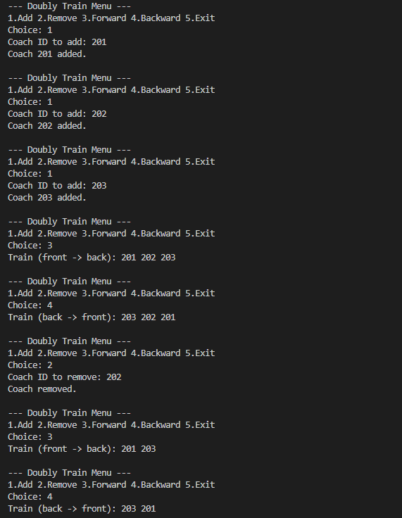

Circular Linked List:

Coaches repeat in output because the list loops back to the first coach. After deleting 302, it cycles only between 301 and 303.

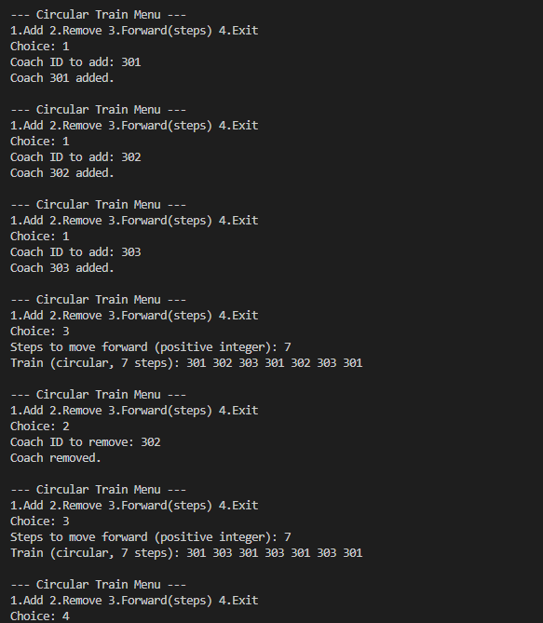

Conclusion:

The simulation of train coaches using linked lists demonstrates how different list structures affect data organization and operations. In a singly linked list, traversal is only possible in one direction, making it simple but limited. A doubly linked list adds backward connections, enabling movement both ways and making insertions and deletions more flexible. A circular linked list connects the last node back to the first, allowing continuous traversal that mimics a loop. Through adding, removing, and traversing coaches in each structure, we can clearly observe their differences in functionality, advantages, and limitations. This assignment shows that while all three approaches model the same concept of a train, the choice of list type depends on the required operations and efficiency.

